RW228A/1204C, RW228B/1204C



DUBLIN INSTITUTE OF TECHNOLOGY
_____________

DT228A/1 MSc in Computing
DT228B/1 MSc in Computing
______________

SUPPLEMENTAL EXAMINATIONS 2015/2016
______________

Probability and Statistical Inference [Math9100]

Ms. deirdre Lawless
Dr. Deirdre Lillis
Mr. Conor sayles

date & Time TBA

Two Hours

SOLUTIONS

Instructions to candidates

Answer question one and one other question.

All questions carry equal marks.

1. |  | A researcher is currently researching hospital care in Ireland. They have developed a theory as part of their research that the length of patient stay in hospital can be predicted by the average number of beds available and nurses on duty in the hospital on the day the patient entered hospital. Their intention is to conduct a statistical analysis of this dataset so that they can extrapolate their findings to all major hospitals in Ireland.  A dataset comprising 114 cases, each representing a single patient, was constructed by conducting an audit of patients discharged during one week from a single hospital. The variables collected are described in the table below. The hospital can deal with 514 patients when operating at maximum capacity and is the second largest hospital in the country and is located in the capital city. There are currently 15 major hospitals operating in the country with similar capacities, two located in the capital but all others located in areas that significantly smaller population sizes than the capital city. The gender ratio in the country is 49:51 male:female. Missing data is not a concern.  Traditionally a 5% cut-off level of statistical significance is used within the research domain.  Question One is continued on next page
  Variables of concern in the dataset
  Name | Label | Comment | Type
  Length | Length of patient stay in hospital |  | Scale
  Gender | Patient gender | 1=male, 2 = female | Categorical
  Age | Patient age |  | Scale
  InfectRsk | Risk of developing an infection | 1=low, 2= high | Categorical
  Beds | Number of beds available on patient admission |  | Scale
  Nurses | Number of nurses on duty on patient admission |  | Scale
  ZLength | ZScore length of patient stay |  | Scale
  Zbeds | ZScore number beds available |  | Scale
  Znurses | ZScore number nurses on duty |  | Scale

1. | (a) | - Comment in particular on the representativeness of the sample and consider the concepts of statistical significance and the role probability plays in this, statistical power, Type I and Type II errors. Identify mechanisms that the researcher could use to address issues you identify.  (18 marks)
Marking:
4 x 3 marks Explanation of statistical significance and relationship with probability and Explanation of statistical power;
6 marks discussion of representativeness and ways to correct (3 marks for issues, 3 for solutions)
Expectations of answer:
Sig:; means the statistic is reliable to cut-off level can conclude level of evidence to reject null hypothesis to this level e.g. 5%=p value 0.05 ; p value is the probability value is the probability of an outcome given the hypothesis
Power: probability of correctly rejecting a false null hypothesis; sample size is key possible in small sample size that even a fairly large population difference would be difficult to detect and no strong conclusions can be drawn about the population; expect consideration of dataset size provided
Type I: incorrect rejection of correct null hypothesis
Type II: failure to reject null hypothesis
Representativeness: Size of dataset is an issue; method of sample collection is an issue; gender representation an issue; Potential solution – weighting for non-response, weighting for design effect, should recognise scaling up for population is not appropriate

1. | (a) | - Examine the information provided on the variables length of patient stay, number of beds available and number of nurses on duty.  Using the information provided in Appendix A, discuss their central tendency, dispersion, in particular skewness and kurtosis. Explain each concept and discuss their impact on the proposed research as well as mechanisms that could be used to address issues identified so that the data could be used in the proposed research.  (18 marks)
Marking:
4 x 3 marks for correct central tendency and spread of each variable plus skew and kurtosis
2 marks for consequences
2 marks for discussion of outliers and how to address
2 marks for discussion of how to address kurtosis of length of stay
Expectations of answer:
Central tendency: single value that attempts to describe a set of data by identifying the central position within that set of data. Expect brief discussion of Mean, Median, Mode
Dispersion: how the data is dispersed around the central measure; Expect brief discussion of standard deviation, interquartile range, range.
Skewness: measure of the asymmetry of the probability distribution – source of bias; discuss skewness statistic; acceptable range +/-2;
Kurtosis: measure of whether the data are peaked or flat relative to a normal distribution – source of bias; should discuss kurtosis statistic; acceptable range +/-2 – should identify kurtosis of length of stay
Outliers: Cases with values very different to majority of data – source of bias; inspect histogram and box plots, normal quantile plot and look at frequency tables; Expect discussion of box plots and zscore frequency tables could also consider histograms; 95% to fall within +/-1.96 none greater than +/-3.29. Outliers do exist and are an issue
Consequences: normality: outliers should address statistical significance, power, type I and type II
Kurtosis – could transform the relevant data; Outliers - Could delete but need to consider impact on sample size, could continue but need to consider impact; could repeat analysis

1. | (b) | Explain what is required to assert that there is a causal relationship between two variables. Illustrate your answer by using the results of the relevant test provided in Appendix A, to interpret the relationship between length of patient stay and number of beds available, length of patient stay and number of nurses on duty and length of patient stay and gender.  (14 marks)
Marking:
4 marks explanation of causal relationship (should discuss association, time order and non-spuriousness)
2 marks selection of correct test based on interpretation provided in part (b)
2 x 3 marks correct interpretation of correlation coefficient and statistical significance
2 marks conclusion about the relationship: moderate correlation that is statistically significant but cannot conclude that one variable is causing change in the other

2. | (a) | The researcher has created a variable znormlength which is a standardised score for length of stay in hospital which has a standard normal distribution. They have decided to use linear regression to explore the relationship between this score and the standardised score for the number of beds available zbeds. The researcher first created a simple linear regression model.  Explain what in this context prediction means. Illustrate your answer by using the additional statistics provided in Appendix B to interpret the model and assess the fit and usefulness of the model considering the coefficients, R², Adjusted R²and F statistic.  (15 marks)
Marking:
3 marks explanation of what prediction is in this context
2 x 3 marks explanation and assessment of coefficients R2 and F statistic
3 marks correct interpretation of the model

Expectations of answer:
Prediction: looking at is the variance in the outcome variable and how much of the variance could be considered to be explained by the predictor variables – should be applied to problem
Regression equation znormlength= 0 + 0.423* zbeds
Coefficients: Measure the strength and direction of relationships between independent variables and the dependent variance – need to consider the significance of these
R2: the proportion of variance in the outcome (dependent) variable which can be explained by the predictor (independent) variables.An R2 of 1 means the independent variable explains 100% of the variance in the dependent variable. Conversely 0 means it explains none.
F statistic: Whether the model as a whole predicts the dependent variable
Its statistical significance is the significance of the model
Fit and usefulness: assessment of R2 and F plus co-efficients: model is statistically significant, TV hrs is a significant predictor, explains 17.9% of the variance
Interpretation: should consider increase in one unit of zbeds and its impact on length of stay

2. | (b) | Differences in the length of stay for different categories of infection risk have been found. Suppose the researcher has extended the model to include infection by incorporating a dummy variable dummyInfect which has a value 0 for low and 1 for high.  - Explain clearly why a dummy variable is needed before using the information provided in Appendix B to state the regression equation, interpret this second model for both low and high risk categories and assess its fit and compare it to the model created in part (a).  (15 marks)
Marking:
3 marks explanation of dummy variable
4 marks correct assessment of model fit and usefulness of model, explains 29.8% of variance, model is significant
4 marks comparison with other model including any change in coefficient for zbeds – improvement in model but change in zbeds which remains statistically significant
4 marks correct interpretation for low and high risk
Expectations of answer:
Dummy variable: interested in effect of characteristic, if include 1 and 2 will act as multiplier, 0 and 1 can see effect and its absence
Assessment of fit and usefulness: Adjusted R2 and Fstat
Regression equation: znormlength=-.346 + .321 * zbeds+ .716*dummyrisk
Should look at model for low and high risk

2. | (b) | - Assess the output for multicollinearity and outliers explaining why these are concerns for multiple linear regression and how you could address these concerns.  (10 marks)
Marking:
2 x 5 marks (2 marks explanation and importance, 3 marks illustration)
Expectations of answer:
Multicollinearity: Occurs when two or more independent variables contain strongly redundant information; If variables are collinear then it means there is not enough distinct information in these variables for MLR to operate – they are essentially measuring the same thing; Examining a correlation matrix that compares your independent variables with each other; coefficient above 0.8 suggests collinearity might be present Consider: VIF = variance inflation factors - Tells you what the standard error would be if the variable was uncorrelated with others; Values of VIF that exceed 2.5 should be cause for concern; Tolerance – should be concerned if it is lower than 0.4. If it is a concern you need to analyse your variables in separate regression equations and then examine how they operate. Correlation not an issue but VIF and tolerance not for data provided.
Outliers: MLR can be greatly influenced by outliers - They ‘pull’ the equation away from the general pattern
Sometimes it is reasonable to delete the outliers; Sometimes you need to retain the outlier – it may be your most important observation; Sometimes it is a good idea to do your analysis twice – once with and once without the outlier to see how much influence it is having on the model
Look at the Minimum and Maximum values next to Std. Residual (Standardised Residual) subheading.
We would expect 95% to fall within +1.96 and -1.96 if our p value cut-off is 0.05 (5%).
If the minimum value is equal or below -3.29, or the maximum value is equal or above 3.29 then you have outliers. Appears to be an issue for this data
Cook’s distance: Measures the effect of deleting a case; Look at Cook’s distance for values greater than one – no major impact by deleting
2. | (c) | The researcher wishes to investigate whether there is an interaction effect between age and infection risk category. They have included an additional variable in the dataset IntAgeRisk which is a combination of age and infection risk category and included this in the regression model created for part (b), the output is shown in Appendix B.  Discuss what an interaction effect is and how it can be assessed using multiple linear regression. Illustrate your answer by referring to the output of the model created, briefly commenting on the fit of the model created and how the new term affects the model.  (10 marks)
Marking:
2 x 2 marks explanation of interaction and explanation of use of interaction term
2 x 3 marks explanation of fit of model and explanation of coefficient and significance of term
Expectations of answer:
An interaction occurs when the magnitude of the effect of one independent variable (X) on a dependent variable (Y) varies as a function of a second independent variable (Z).
Add an interaction term to the model – new variable is an interaction term, allows exploration of whether the effect of risk is different for different ages
Improves fit of model, term is statistically significant, should discuss changes in other coefficients

3. |  | A researcher has collected data on patient attitudes about their hospital experience. They conducted a survey using a recognised attitudinal scale which has been found to be reliable. They wish to incorporate a single measure of patient satisfaction with their experience. They wish to conduct a PCA on these variables to create this measure. The data contains 254 cases.  - Explain clearly the objectives of principal component analysis (PCA) and when you would use this technique.  (6 marks)
  Variable Name | Label | Values
  perf_1 | Performance: Good standard of care | 1(Extremely Good) to 10 (Extremely Poor)
  perf_2 | Performance: Good value for money | 1(Extremely Good) to 10 (Extremely Poor)
  perf_3 | Performance: Good availability of staff | 1(Extremely Good) to 10 (Extremely Poor)
  perf_4 | Performance: Bills are clear | 1(Extremely Good) to 10 (Extremely Poor)
  perf_5 | Performance: Convenient Visiting Hrs | 1(Extremely Good) to 10 (Extremely Poor)
  perf_6 | Performance: Good hospital to be in | 1(Extremely Good) to 10 (Extremely Poor)
Marking:
3 marks objectives of PCA; 3 marks explanation of use
Expectations of answer:
Objectives: Reduce the number of variables; Evaluates the construct validity of a scale, test, or instrument; Development of parsimonious (simple) analysis and interpretation; Addresses multicollinearity (two or more variables that are correlated)
Used to reduce multiple observed variables into fewer components that summarize their variance; All of the variance in the variables is used. Reveals principal components underlying structure of the data

3. | (a) | - Discuss the suitability of the dataset. In your answer, using the information provided in Appendix C, you should in particular examine the descriptive statistics on each of these variables, details of correlations between them and the reliability of the scale to determine if PCA is possible.  (18 marks)
Marking:
Marking:
3 marks Sample size and sample to variable ratio (1 for explanation, 2 for interpretation); 3 marks examination of the descriptvies – in particular missing data; 5 marks Factorability of the correlation matrix (2 for explanation, 3 for interpretation); 4 marks Kaiser-Meyer-Olkin (KMO) /Bartlett's (2 for explanation, 2 for interpretation); 3 marks Reliability – Cronbach’s alpha (1 for explanation, 2 for interpretation)
Expectations of answer:
Sample size, sample to variable: generally at least 300 cases needed; N:p ratio where N = no of cases, p=no of variables rule of thumb 10:1. Not an issue here. Alternate rules may be accepted; There are some concerns here but 100+ is acceptable
Factorability of the matrix: looking at relationships between individual variable; correlation coefficients >0.30 indicates that the factors account for approximately 30% relationship within the data, or in a practical sense, it would indicate that a third of the variables share too much variance – good indicator. If no correlations need to rethink use. Here have correlations between value for money and availability of staff, clear bills, visiting hrs, value for money and good hospital to be in, availability of staff and visiting hrs, good std of care and availability of staff, good hospital and bills clear approaching 3.0
KMO proportion of variance in variables that might be caused by an underlying factor. High values close to 1 suggest that FA useful, anything less than 0.5 FA won’t be useful. Bartlett tests that variables are correlated. Looking for a statistically significant p value which suggests that they are related and a FA would be useful. No issues for this data.
Reliability accuracy and precision of a measurement procedure; Cronbach’s alpha – index of reliability associated with the variation accounted for by the true score of the "underlying construct"; Acceptable level depend on the purpose of the instrument. Acceptable 0.60. For this data it is 0.75 – good reliability

3. |  | Explain how PCA works focusing on extraction and loading. Illustrate your answer by interpreting the output of the PCA conducted for this research using the information provided in Appendix C.  (20 marks)
Marking:
5 marks extraction (2 for meaning, 2 for application)
5 marks communalities (2 for meaning, 2 for application)
5 marks variance (2 for meaning, 2 for application)
3 marks loadings
2 marks correct identification of component
Expectations of answer:
Extraction: aim is reduce a large number of items into factors. Need to decide how many factors to retain. Criteria for extraction: Kaiser’s criteria (eigenvalue > 1 rule), the Scree test, the cumulative percent of variance extracted.
Rotation: Unrotated results from a factor analysis are not easy to interpret, although the plot helps. Rotation helps clarify and simplify the results of a factor analysis. Conceptually, the axes are being rotated so that the clusters of items fall as closely as possible to them. Making the factor loading pattern much clearer as one of the two pairs of coordinates for each item tends to be close to 0.00
Variance: Looking at total variance explained for factors with eigenvalues > 1; component 1 explains 46.89% of total variance; single component
Communalities: proportion of the common variance within a variable; looking at extraction column – all above .3
Except for good standard of care; Should look at component loadings before rotation and after to see difference
Should draw conclusions about the number of components and variance explained - single component – conforms to what researcher was expecting.
3. |  | Briefly explain the differences between PCA and exploratory factor analysis.  (6 marks)
Marking:
4 marks use; 2 marks variance
Expectations of answer:
Differences/Use EFA and PCA: EFA Determine the nature of and the number of latent variables that account for observed variation and covariation among set of observed indicators; Used to develop theoretical constructs; Used to prove/disprove proposed theories; only shared variance is used; PCA Reduce multiple observed variables into fewer components that summarize their variance; All of the variance in the variables is used

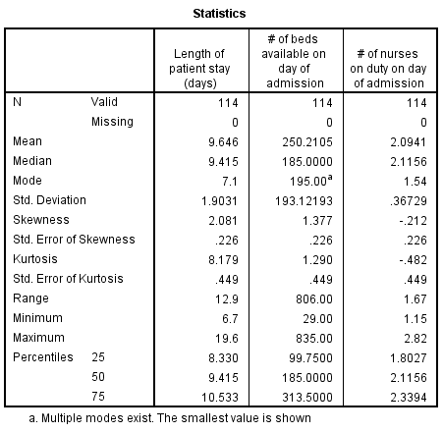 | 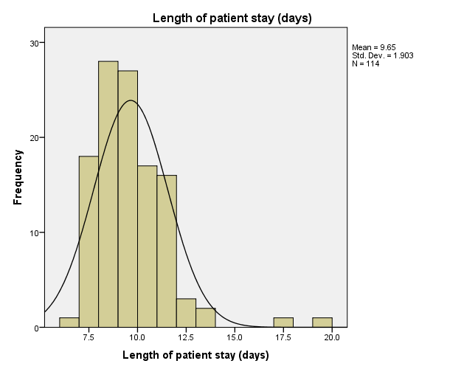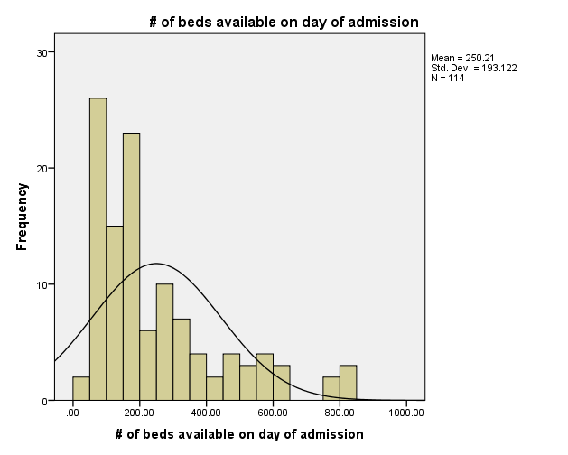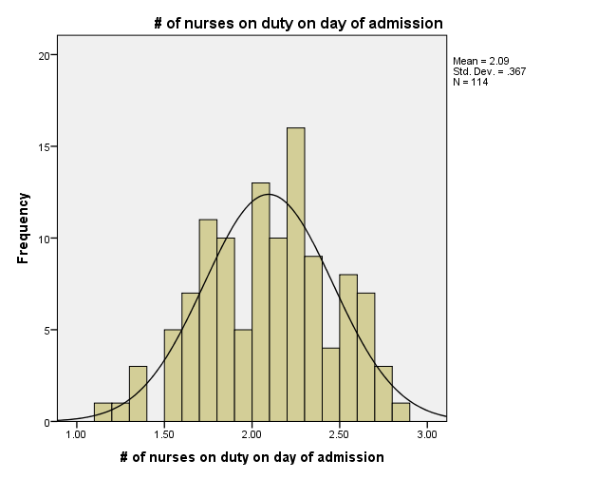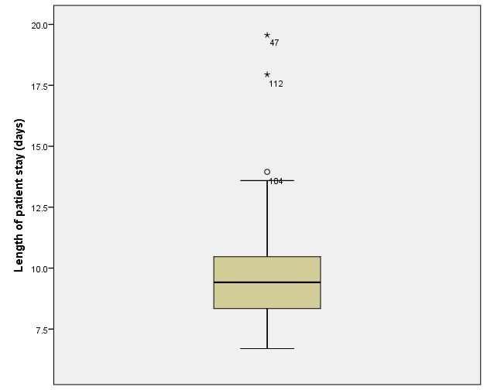  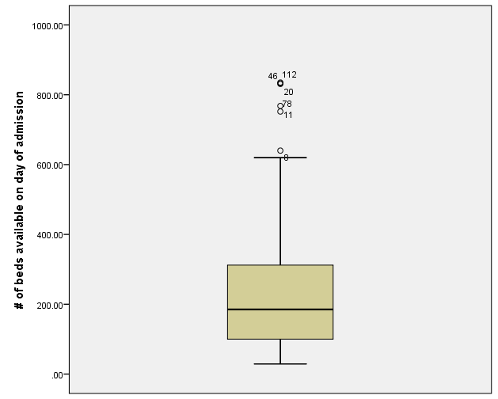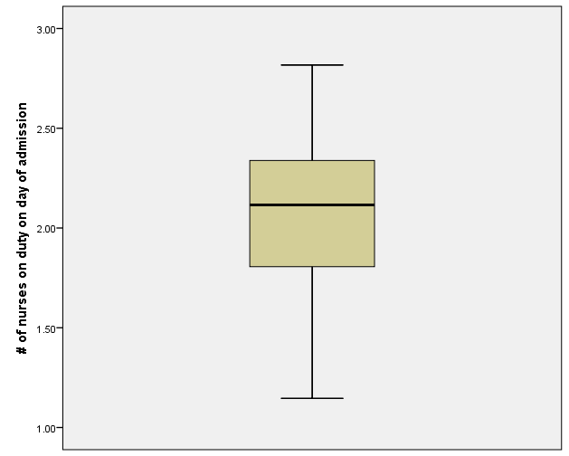
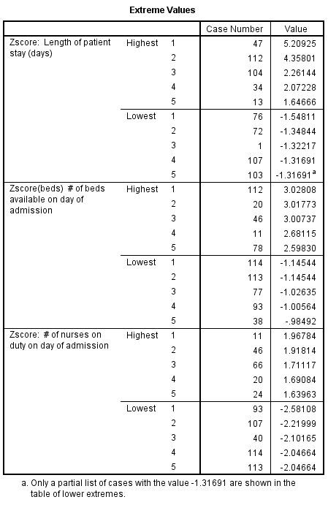 | 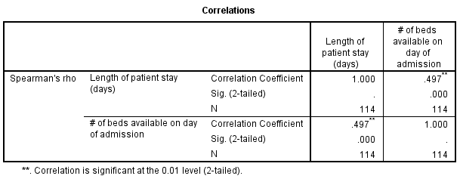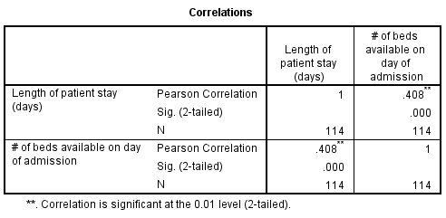

Model for Q2(a) |  | Model for Q2(b)
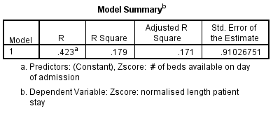 |  | 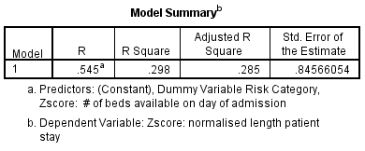
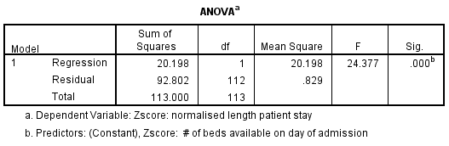 |  | 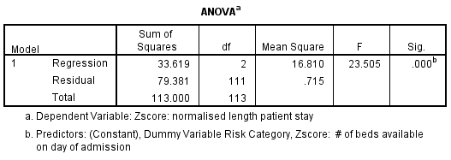
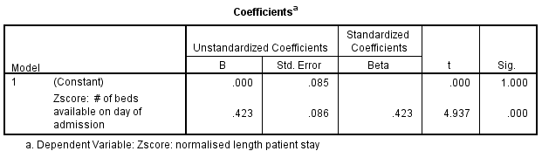
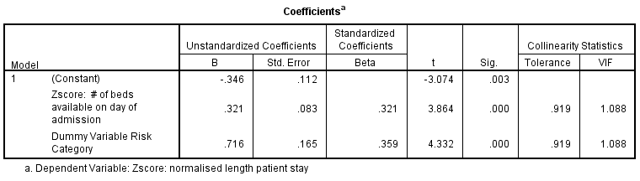
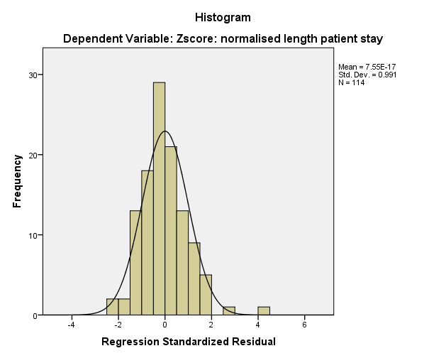 | 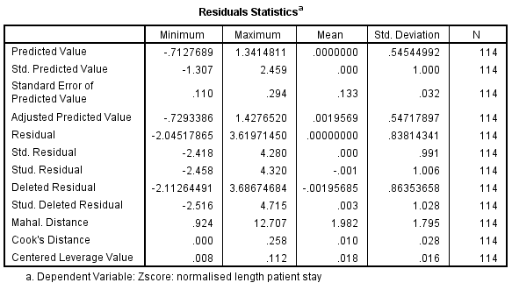
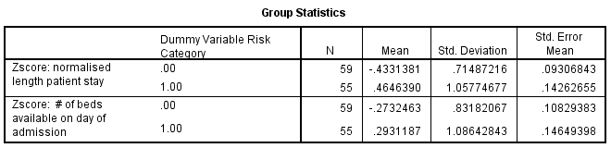
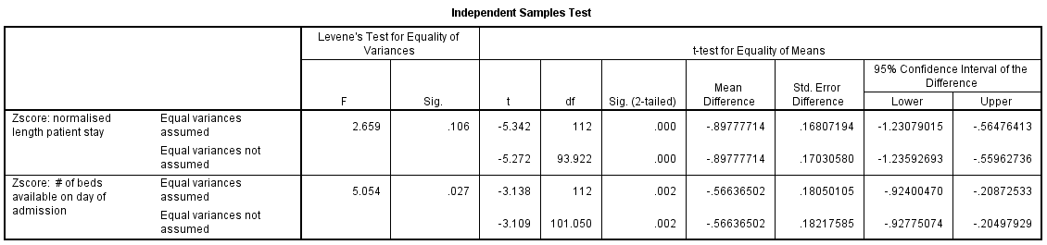

Model for 2 (c)
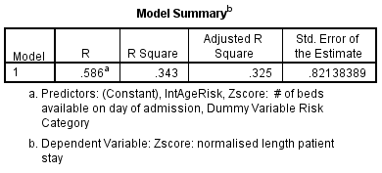 | 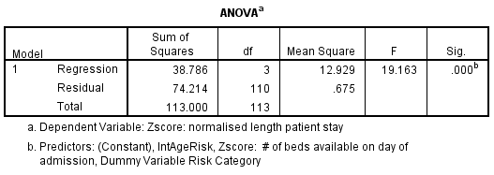
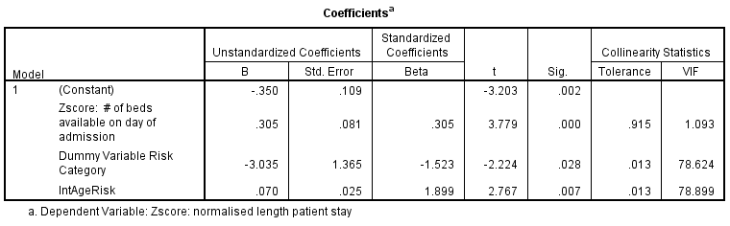

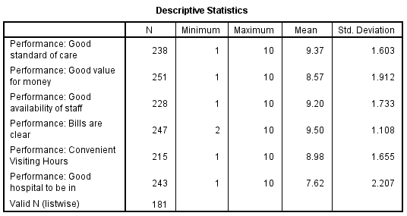 |  | 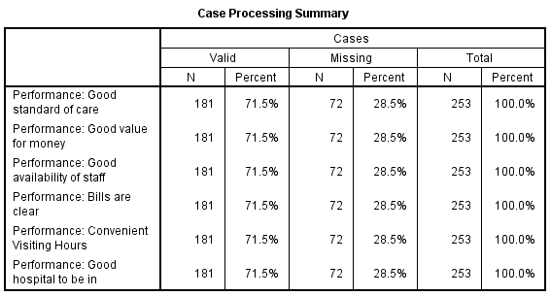
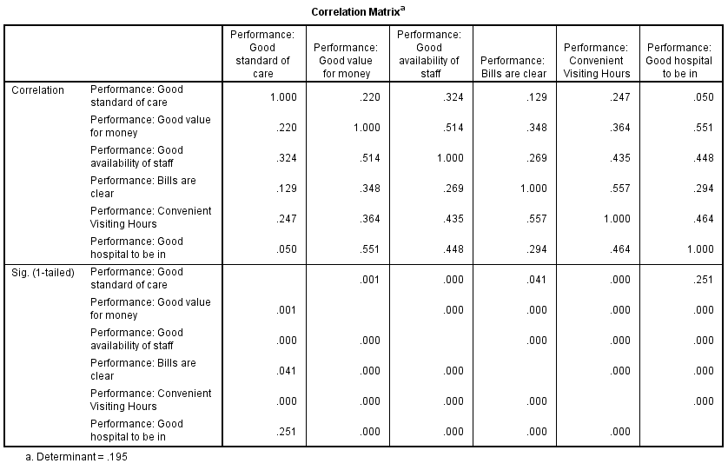
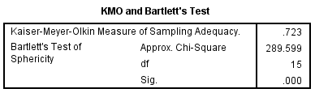  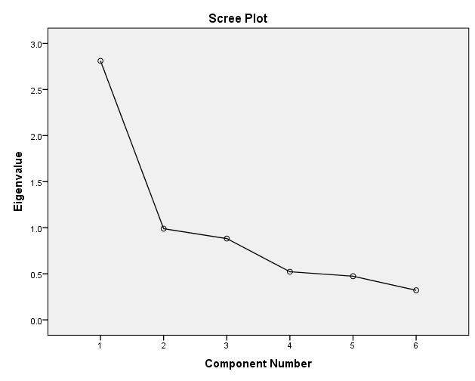 | 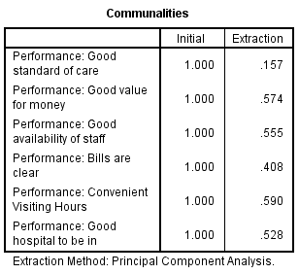
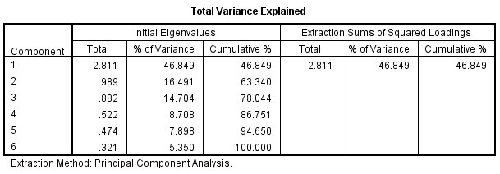 |  |  | 